Pizza Crust

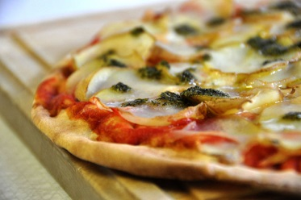

*Photo by [cyclonebill](https://www.flickr.com/photos/23178876@N03/3635741167/).*

George has bought a pizza. George loves cheese. George thinks the pizza does not have enough cheese. George gets angry.

George’s pizza is round, and has a radius of RR cm. The outermost CC cm is crust, and does not have cheese. What percent of George’s pizza has cheese?

**Input**

The input consists of a single line with two space separated integers, RR and CC.

**Output**

Output the percentage of the pizza that has cheese. Your answer must have an absolute or relative error of at most10−610−6.

**Limits**

* 1≤C≤R≤1001≤C≤R≤100

|  |  |
| --- | --- |
| **Sample Input 1** | **Sample Output 1** |
| 1 1 | 0.000000000 |

|  |  |
| --- | --- |
| **Sample Input 2** | **Sample Output 2** |
| 2 1 | 25.000000 |

<https://open.kattis.com/problems/pizza2>

using System;

using System.Collections.Generic;

using System.Linq;

using System.Text;

namespace ConsoleApplication1

{

class Program

{

static void Main(string[] args)

{

//double r = 2, c = 1;

string[] input = Console.ReadLine().Trim().Split(' ');

double r = double.Parse(input[0]);

double c = double.Parse(input[1]);

double num = (r-c) *(r-c) * Math.PI;

double den = r*r * Math.PI;

Console.WriteLine((num / den) * 100);

Console.ReadLine();

}

}

}